## **J. FRAGRANCE**

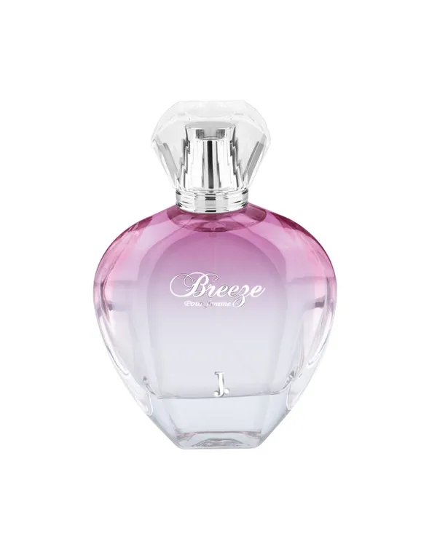

**Breeze Perfume For Women**



**PKR 3,375.00~~PKR 4,500.00~~**

**J. truly captures the soul of a modern woman with a character that is delicate yet intricate in its fine fragrance creation by the name of Breeze. The fragrance is a passionate, graceful, and tender assortment of floral and woody origins. It opens with citrusy accords of bergamot leading to the exotic floral heart of ylang-ylang, Casablanca lily, and orange blossom. Intense notes of sandalwood, Tahitian vanilla, and amber form the base that acts as the final act of the series.**

**Size: 80ml Bottle**